**Steps to run the test project**

**Prerequisites:**

* Google Chrome Version 88 installed.
* .Net core SDK 3.1.406 installed (if running via command line).
* It can be downloaded from <https://dotnet.microsoft.com/download/dotnet/3.1>

Tools that may be required to execute the test. There are two options

1. **Run via command line**

The dotnet test command is used to execute unit tests in a given solution. The dotnet test command builds the solution and runs a test host application for each test project in the solution. (I have tested on windows machine)

* Open downloaded project folder for the repository (GitHub or Onedrive)
* Go to folder where you can find *.csproj
* Run following command to execute tests

dotnet test WpacTestProject1.csproj

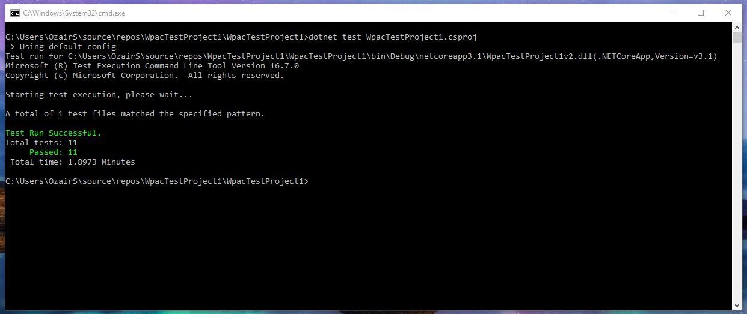

1. **Run via Visual studio 2019 community:**

* Open Visual studio.
* Open downloaded project folder for the repository (GitHub or Onedrive)
* Build the solution from the ‘Solution explorer’
* Under test menu click on ‘Test Explorer’
* Run all tests.

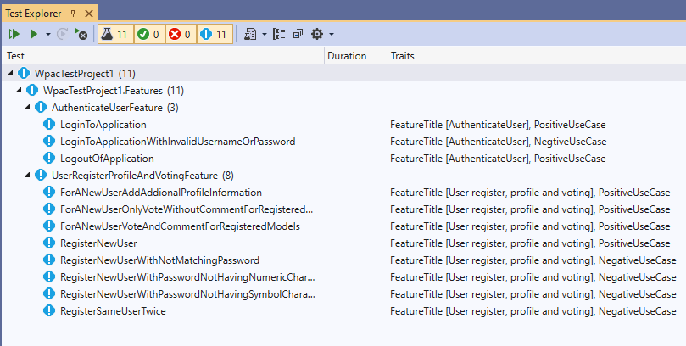

**Test project details:**

Solution is created in Visual studio with Project template ‘MSTest Project’.

Speck flow is used to write tests in Given/When/Then formats.

Folder “Feature” has all the files with requirements mentioned in Given/When/Then format

Folder “Steps” have actual test implementation.

Folder “Pages” has page object model of pages.

